June
I will keep updating our website on what I work on weekly or even daily when I can.
http://bayislandbonsai.com/news/

Jonas has also done a great job on keeping his site informative.
http://bonsaitonight.com/

Spring Care: Most bonsai grow quickly in June — this means you need to pay close attention to your entire collection.

Developed black pines are decandled this month. Depending on each tree’s spring growth, decandling may be done all in one day or spread out over several weeks to balance uneven growth. Remove fertilizer from strong pines after they have been decandled.

Although most pines that are not being decandled should be fertilized moderately, very weak trees receive less fertilizer and a suitable amount of water.

Note: It has been a cold year. black pine seems to grow slower . after decandling, fertilizer should be left on the tree though summer. Some trees still grow strongly. Do not fertilize for 4-6 weeks.

Note: Decandle strong Japanese black pine and well fed trees only.

If you live in the
Northern part of the USA - decandle around the end of May to the first week of June.
San Francisco Bay area. - decandle around first or second week of June.
Los Angeles area - decandle around second week to third week of June
Mid West - decandle around third week to the end of June
Southern US - decandle around the first week to 2nd week of July
Deep South - decandle around the 2nd week to the end of July.

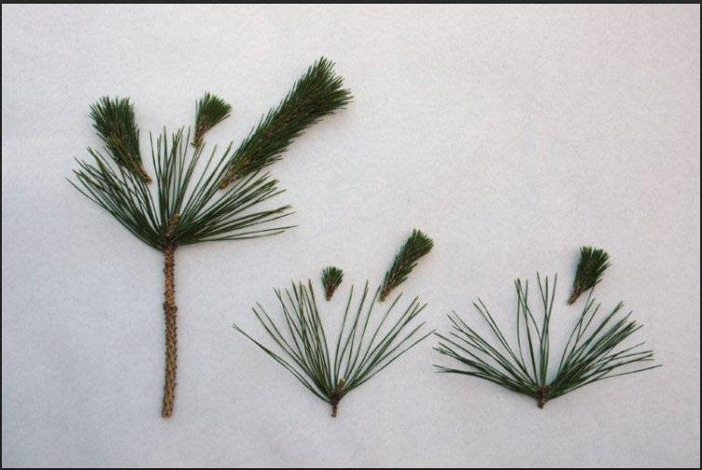

Strong leave longer stubs- medium size leave some stub – small not stub

Let white pines grow this month. Fertilize weaker trees lightly. Fertilize all white pine in mid August.

Deciduous trees usually send out another flush of growth in June. Check the wire. If necessary, remove wire that is digging in and re-wire.

-Trident maple - Strong growth on developed trident maples may be defoliated, partially defoliated, or removed.
-Chinese quince - Let new shoots grow to about 12 inches (8-10 leaves) before cutting back the new shoots to two or three leaves.
-Japanese Maple - you can partially defoliate strong trees. (I usually do not defoliate the whole tree every year). Remove large leaves on the strong area and leave smaller leaves alone. Another technique for more mature tree is to remove one leaf from every pair. For shohin, after removing one leaf you can cut the other leaf in half. Cutting the leave in half will keep the bud smaller
- Shimpaku – for a refined tree – pinch runners. do not pinch trees in development.
As the weather heats up, protect deciduous trees from excessive heat and sun, especially after defoliation. Partial defoliation exposes shady leaves to full sun. Letting these leaves burn slows summer growth.
-Spruce, yew and hemlock – if the new grow is still soft, do not fertilized. The new growth will become leggy and long. In the bay area, it is too late to pinch new growth on finished tree. Wait until it is hardened off. Then use scissors to cut back to new buds.

Broad leaves tropical trees (Ex. Ficus, Buttonwood) – defoliate finished trees only. If you defoliate the trees in training, they will not grow correctly. The correct way to develop bonsai is to let them grow – then wire and then let those branches elongate – then cut them back and leave a few leaves at the base and let new shoots grow and then wire them again(you should get 2-3 new shoots the 2nd time around. At this stage of training - do not worry about big leaves. You need to let it grow. Fertilized your tree in training early and often. You can repeat this technique until it reaches the desired outline.
Then the refinement starts.

On refined broad leaves tropical tree. Let the new leaves grow to 5-6 leaves then cut to 2-3 leaves. If the old leaves turn yellow, you can remove them. Otherwise, wait until the new leaves harden off then cut off the old leaves. Do not fertilize until the new leaves hardened off. (this is different to trees in training)
If the new leaves are big, cut them in half (weaker tree) or defoliate strong exterior part only. Leave the smaller leaves in the interior alone. If you want to increase the thickness of the bottom branches, let the tip of those branches grow freely. Cut them back after those branches reach the desired thickness or length.

Tropical trees can be repotted during summer months.

Once 3/4 of the flowers on a satsuki azalea have opened, remove all of the flowers from the tree. Cut back to 2 new leaves on 2 new shoots in strong areas (lower part and exterior parts of the tree). Cut back to 2 new shoots and keep 3 new leaves on weaker area (upper parts of the tree). Remove shoots growing straight up or down. Now is the best time to wire azalea.
If the new shoots are very small, it indicates that your satsuki azalea is weak. Do not let it bloom next year. That will help it to regain strength. I usually remove them in fall or winter.

June is a good time to spray insecticide, but use caution. Some insecticides may burn foliage in hot sun.

Do not let the trees dry out. Wiring and styling the trees that are dry or wilted can cause more stress to the trees.

Turning trees:
We should turn our trees 180 degrees once a month. Or 90 degree every other week.
This will keep our trees in god balance. Every branch will get the same amount of sunlight.

Suitable trees to work on this month.
-Japanese black pine – decandle
-Junipers
-Azalea
-deciduous trees
-tropicals.

